**URL: http://www.kfmc.med.sa/**

Is the King Fahd Medical City in Riyadh, one of the largest independent medical cities in the Middle East, including: hospital president, Women's Hospital Specialist, Children's Hospital, a hospital rehabilitation. The city has four centers: the Prince Salman Center for Medicine and Surgery, Center for Neuroscience, Prince Salman Center for Diseases blood and tumors, and Antrzalt_khassi of Diabetes and Endocrinology.

**Vision:**   
To be the best in the provision of curative services and training using the best and I represent.

**Our Mission:**

To provide the best diagnostic and therapeutic services, rehabilitation and development of local human resources through its team of loyal, honest and distinct.

**Objectives**

Contribute to improving the health of citizens and improve it.   
 Contribute to the establishment of rules and high standards for the practice of medicine.   
Diagnosis of complex medical cases referred to it by hospitals and other health facilities and treatment.   
 Development of human resources in various areas of health and management through education and training in various levels.   
 Conducting research and health studies.   
 Provide consultancy specialized medical and other health facilities.   
Contribute to raising awareness and health education.

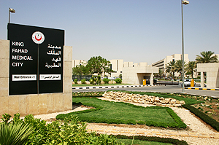

I could not procure much data as the details are transcribed in Arabic language.